**Year 13 Assessment Template – Designing a database-driven website – AS91891**

## Stage 1 – establishing exactly what your design requirements are

Context: For example, photo sharing site, Mexican restaurant, St Andrew’s centenary

Music sharing web site.

Purpose of the site: i.e. What should the site achieve if it is successful? E.g. Should enable users to see photos I have taken. Should enable users to see all items on the menu.

The purpose of the website is so people can post music they have created and share with other people on the site. Once they have created an account, the web site will let them Upload there music and also delete there music if they don’t like what they posted.

End-user requirements: What specific functionality will the end-users require? E.g. Users can search for photos by topic in a search bar, users can select categories of photos to make it easier to find what they are looking for, users can post comments about the photos.

End-user requirements my web site will let users create an account and upload their own music and also delete there own music. You will be able to scroll through the web site like Instagram and Facebook. You will scroll through it and the most recent posts will be at the top and as you scroll down it will go to the older and older posts. There will also be a search bar were you can look up peoples accounts, to view there music.

Relevant implication 1: Identify a relevant implication that you need to consider. Describe what it is and explain why it is important that your design and final website meets this implication.

Aesthetics: My first relevant implication is Aesthetics. The point of Aesthetics implication is to, make it look good and have a pleasing. The good thing about having a good Aesthetics means that people will enjoy your site and come back again to use your site. Also having a good Aesthetics also means having a nice simplistic design which will also help it look better and will also help with functionality. This is impornat to my wesite becaeus it will look bad with out it and I will address it by using css.

Relevant implication 2: Identify a relevant implication that you need to consider. Describe what it is and explain why it is important that your design and final website meets this implication.

Usability: With usability I will make my website simple and usable. The good thing about having a simple web site is that it helps with functionality and Aesthetics. I will have a constant theme through the hole website Eg colours consistant through the site, links/navbar in the same place on each page. It is important so people will come back to my site again and again. I will address this by making my wesite simple by using php and bootstrap.

Research: Show screenshots of websites you have looked at for inspiration. Include comments about what features you liked and would like to incorporate into your own design.

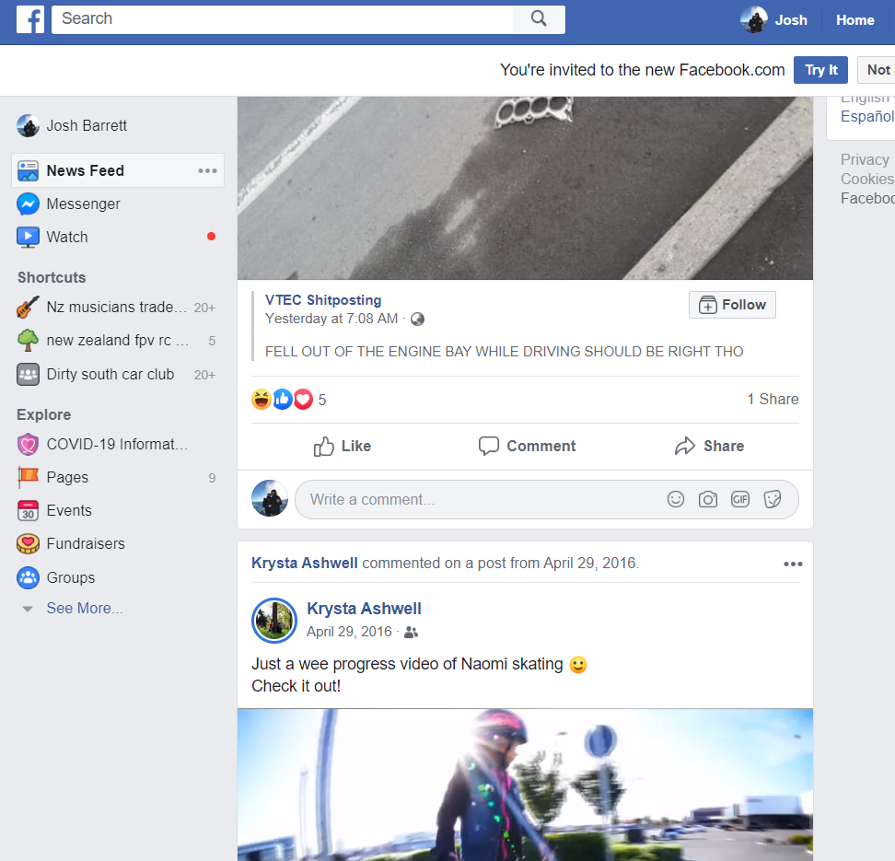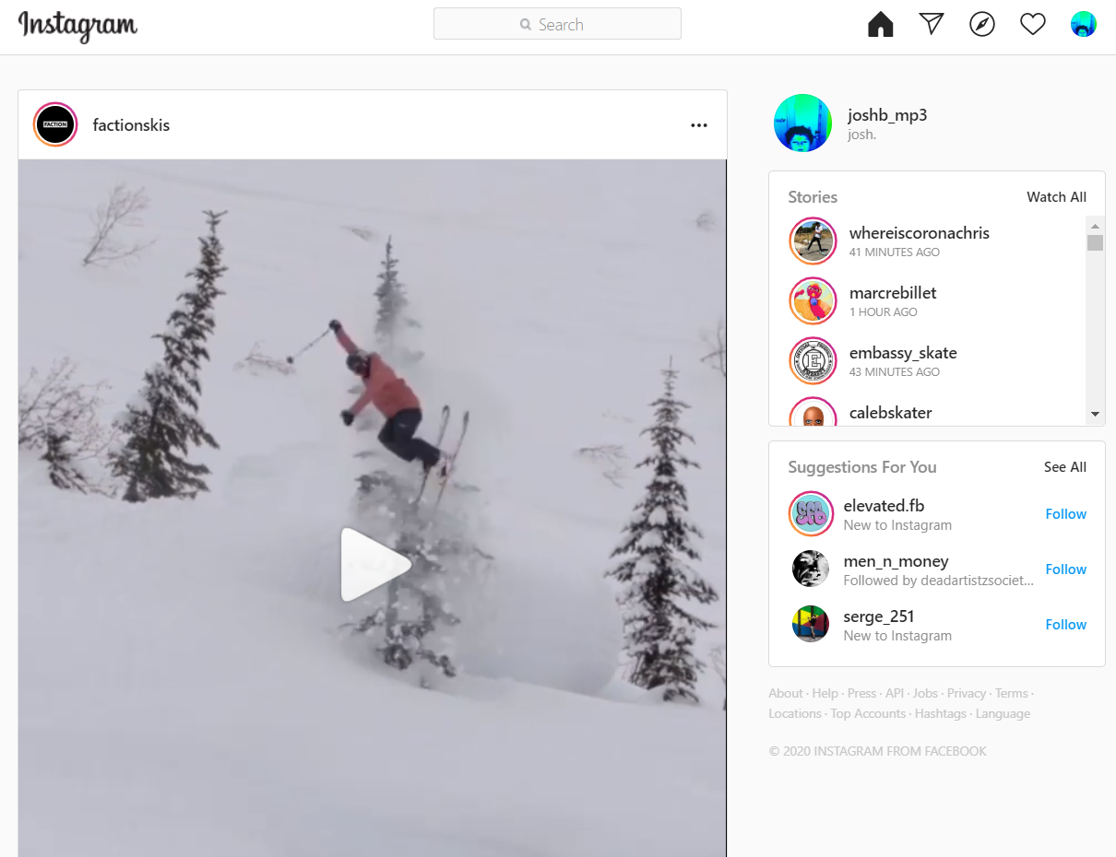

Colour palette: Try to come up with a colour scheme you can use on your design. You can include screenshots of the colour palette, plus colour codes in hexadecimal or RGB format. Use sites like Colour Lovers or Coolors for ideas.

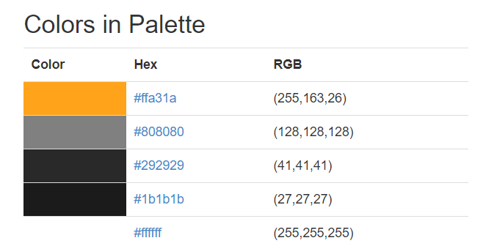

Fonts: Decide what fonts you will use on your site. These can be standard fonts like Arial or less common fonts if you wish. Keep in mind for uncommon fonts you will need to either link to them or download them into your project folder.

"**Helvetica Neue**", **Helvetica**, **Arial**, **sans-serif**.

## Stage 2 - designs

Initial designs

Design 1: Include screenshots of your initial designs here. These will not just be the home page but should show roughly what other pages will look like as well. Include colours and fonts if you can.

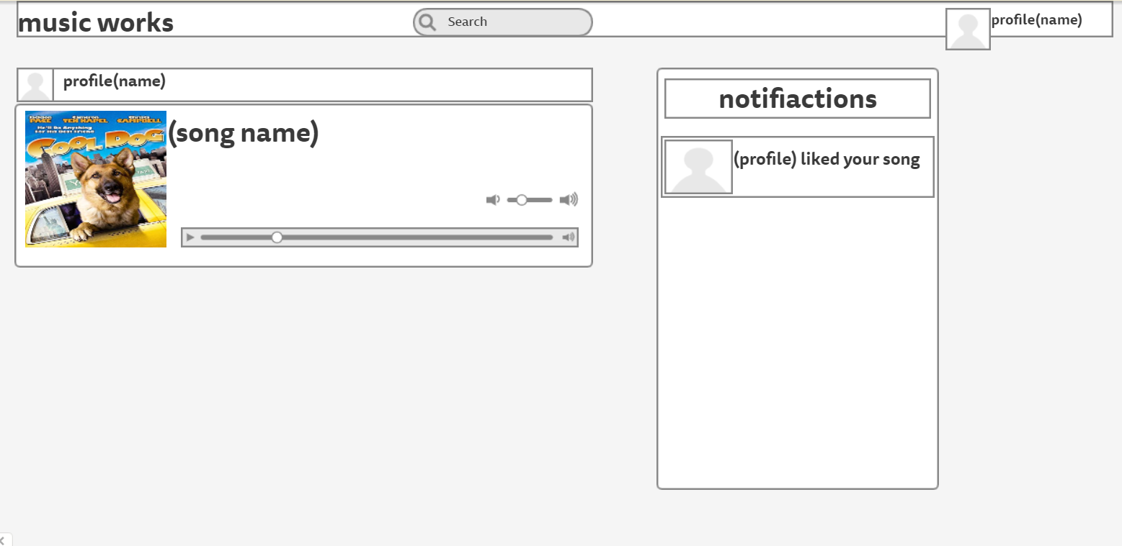

Home page ^

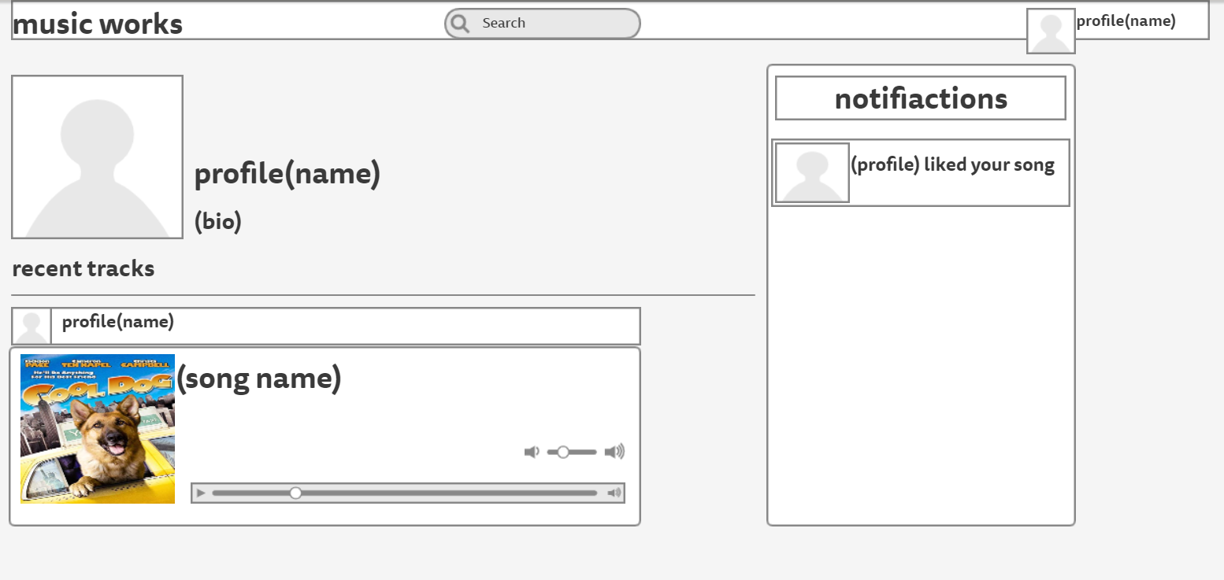

Proflile page^

Design 2:

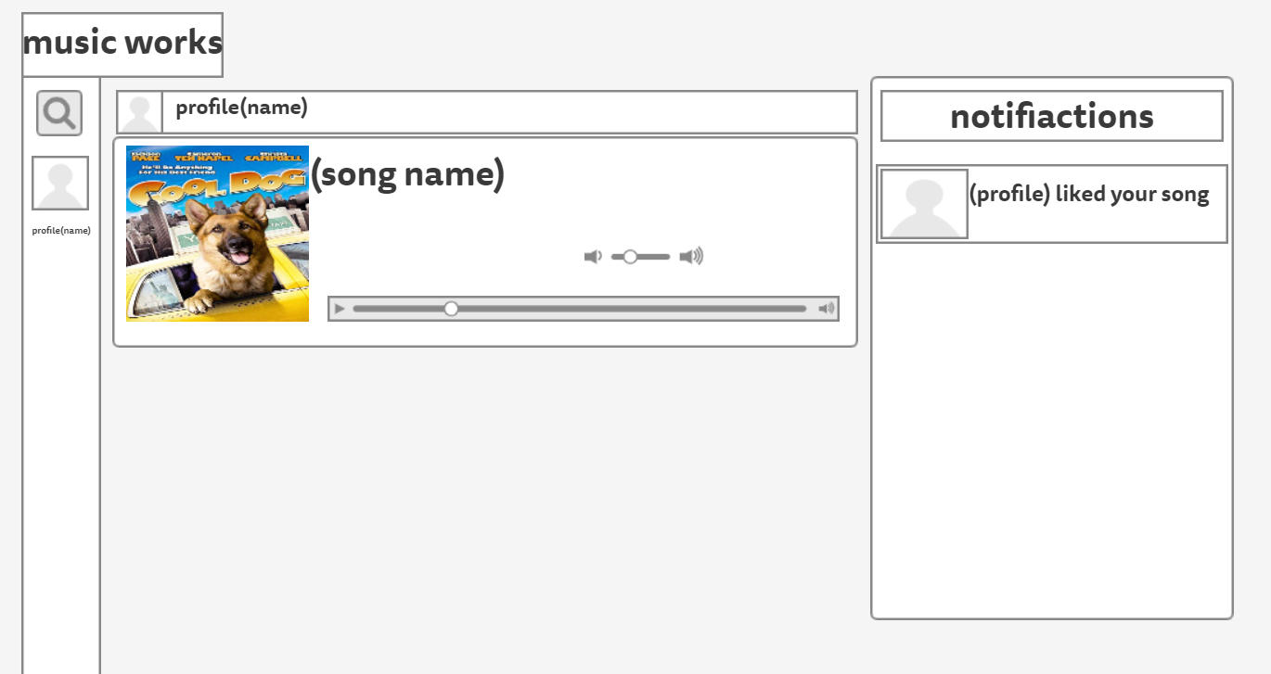

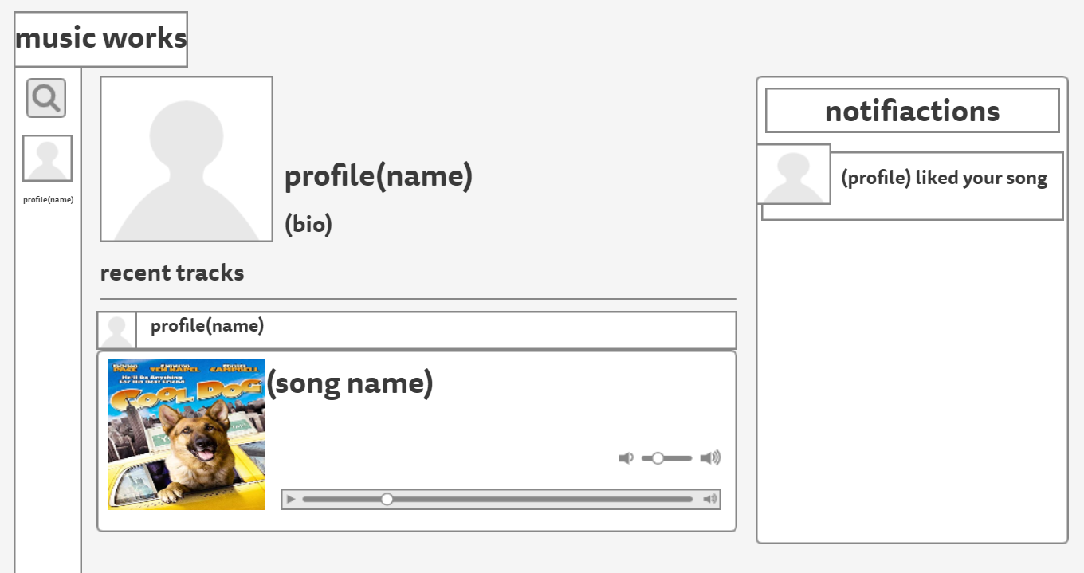

Feedback on design 1 Get feedback on each design from at least two classmates. Write it down below.

Student name: finn g

Feedback: Need more colour

Student name: james

Feedback: you need to know that you need to scroll down

Feedback on design 2

Student name:andrie

Feedback: needs colour

Student name:ethen

Feedback: the bar that the logo is in needs to go across the hole page

Updated designs After getting feedback, make changes to address the feedback. Include screenshots of the updated designs below.

Design 1: 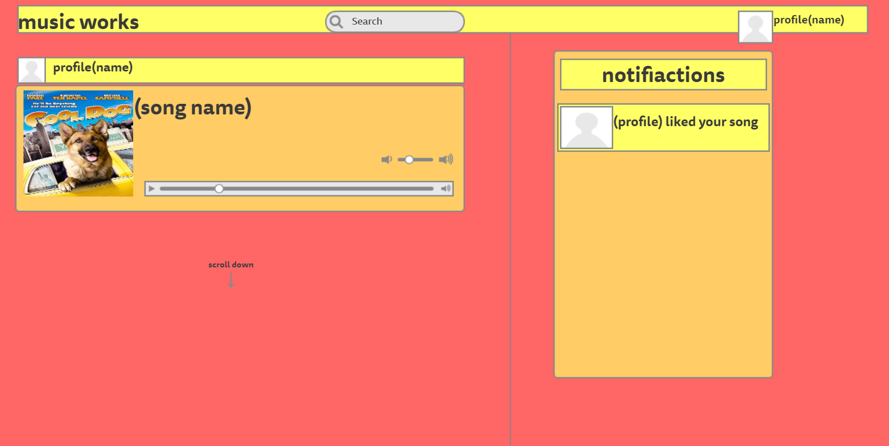

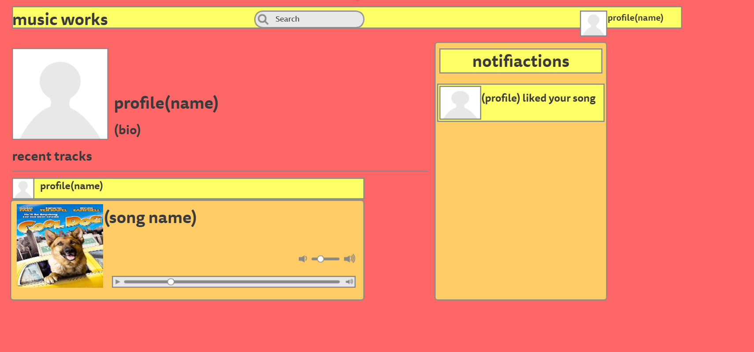

Design 2:

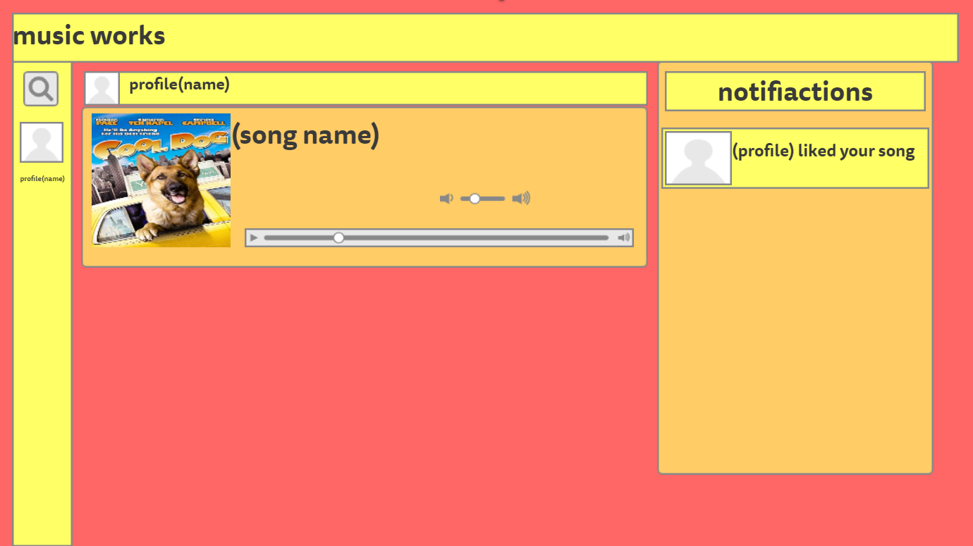

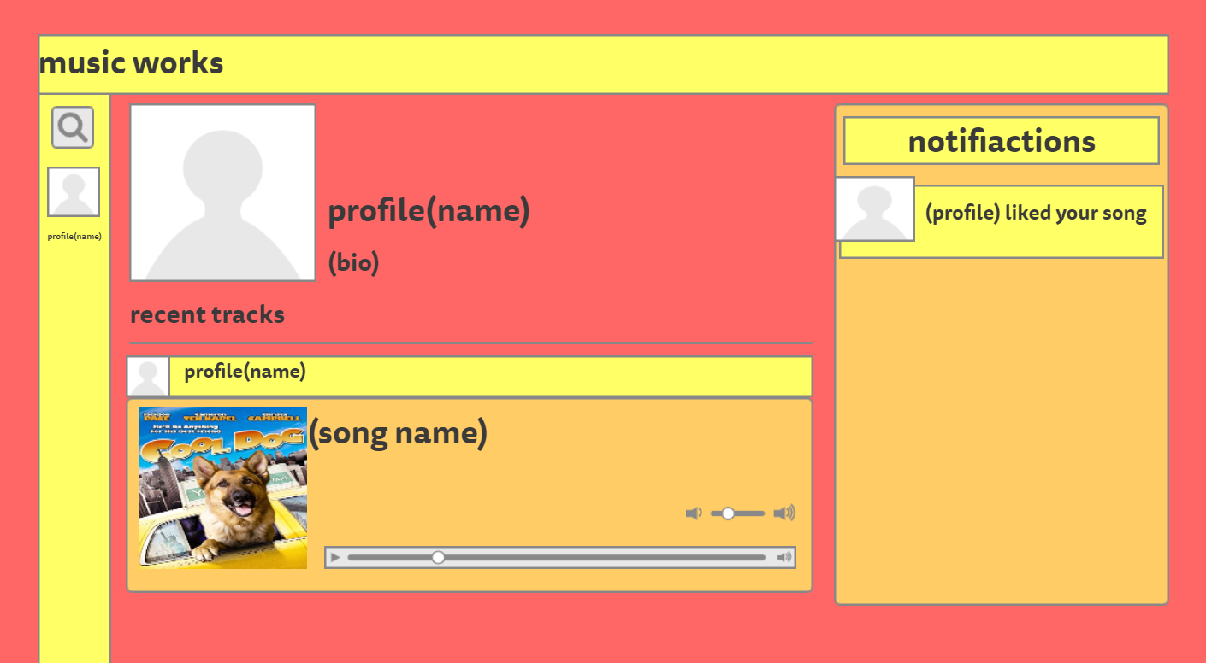

Feedback on updated design 1 Get feedback on updated designs from at least two classmates. Include comments below.

Student name: james

Feedback: hate the colours please change

Student name: Andrei

Feedback: please change the colours and also don’t have a profile page just have a page showing the users music so its more simple and easy to code.

Feedback on updated design 2

Student name: james

Feedback: “colours are the same still looks bad, you should use dark colours”

Student name: finny

Feedback: needs better colours and also don’t have the users profile thing it will make it too hard.

Proposed final design: After feedback from classmates and updating the designs, you should be able to decide which design is better now. Include screenshots of this design below.

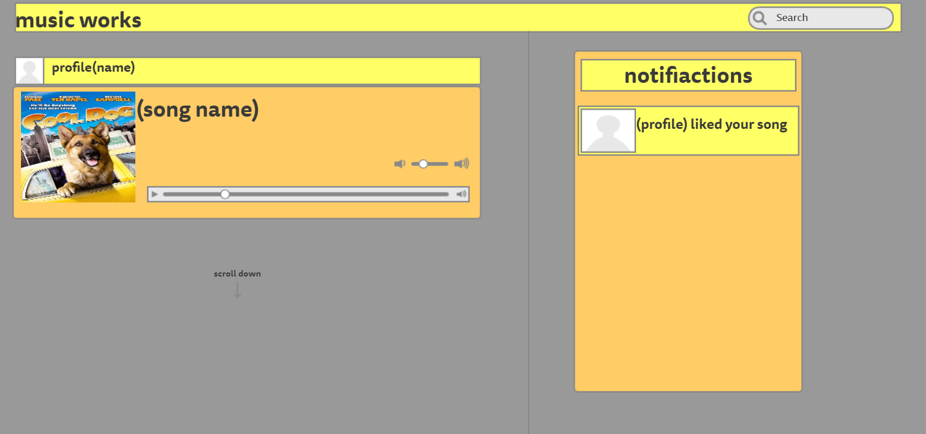

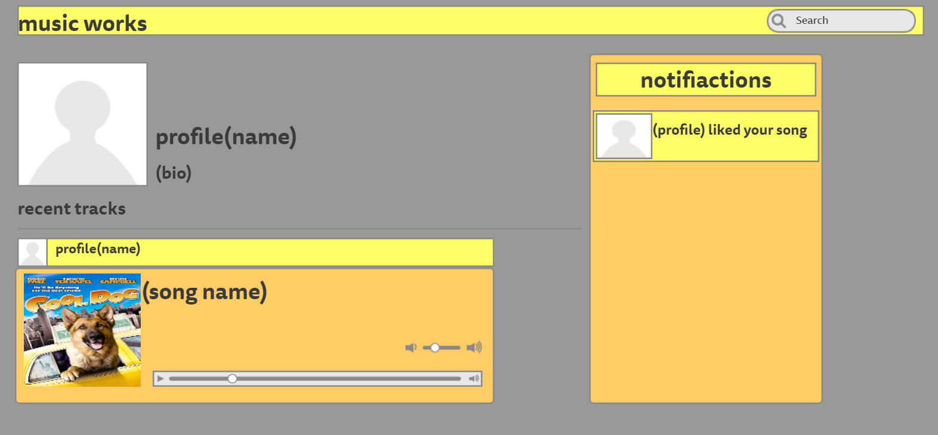

Feedback on proposed final design Get feedback on your proposed final design from at least two classmates. Include comments below.

Student name:james

Feedback: yea its better but still I think you should have no colours like Instagram.

Student name: finn

Feedback: It still looks kruddy and basic I think you should make it look a bit

## Stage 3 – Final design decision and justification

Updated final design Include screenshots of your final design below. These should cover all pages in your site.

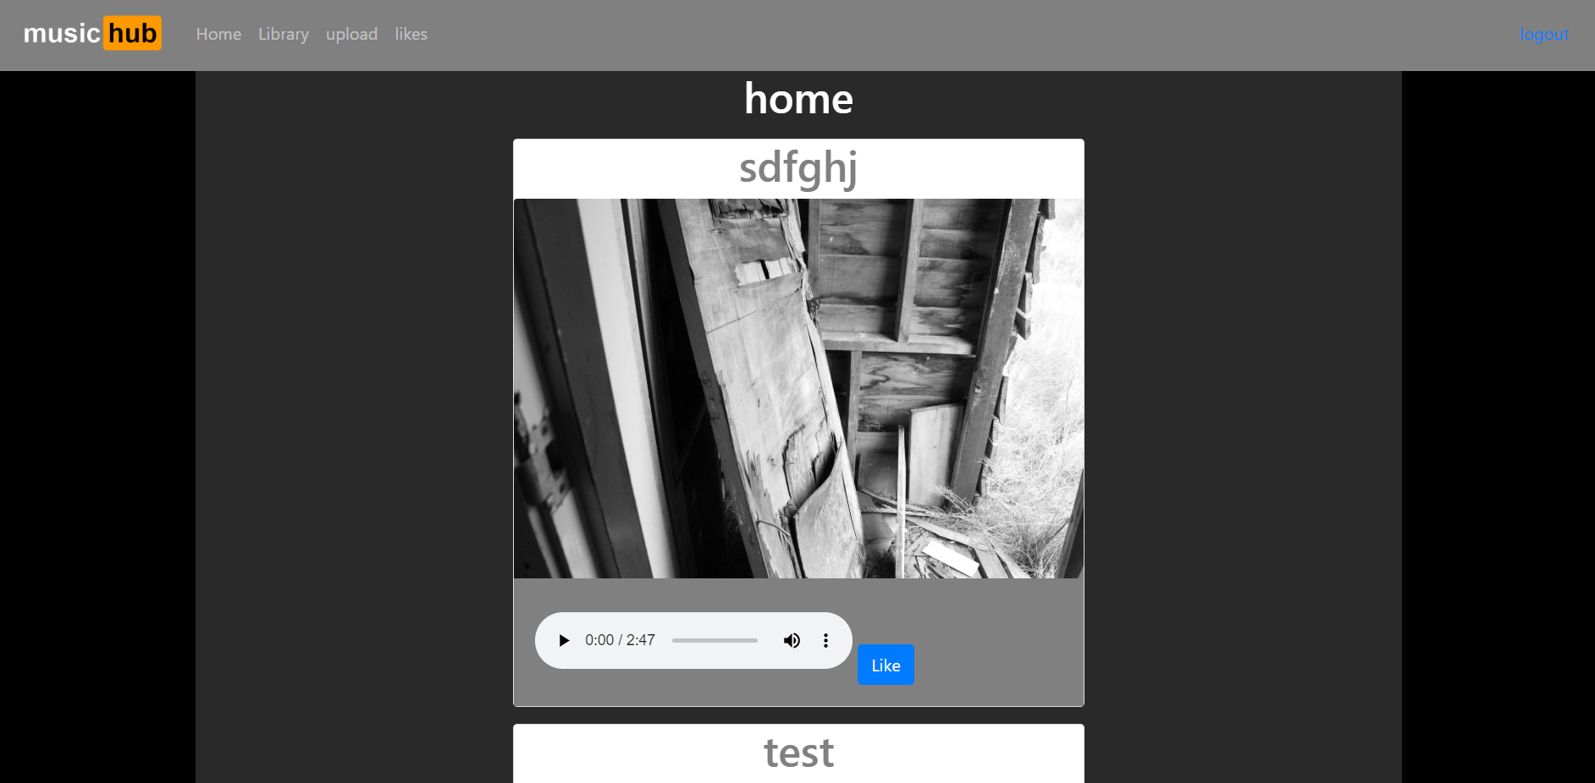

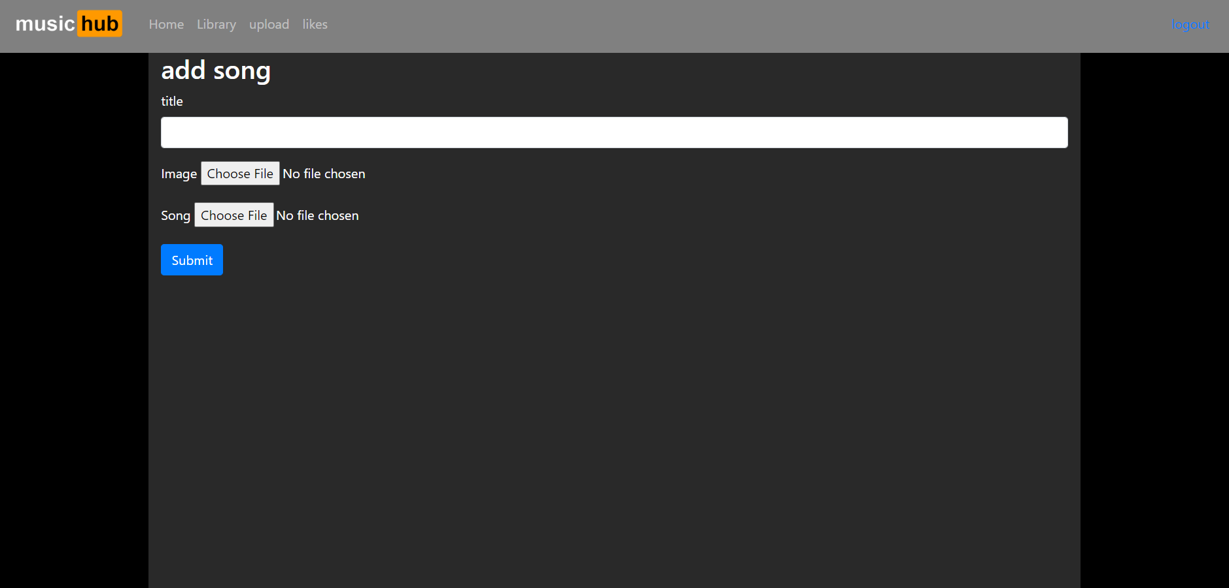

Evaluation of the final design

Design conventions: Explain how your design has addressed usability heuristics and visual hierarchy. Justify decisions for Excellence.

I have acheaved my two relivent implications. I have acheaved my usibilty implication because I have made my website simple. I made it to my log in and out button is on the top right hand conner just like in other sites, I also made it so the home page link is the logo and stuff like that so it is visually pleasing abut also easy to use. My other implication was usability, I wanted to make it so it was super easy to use my site and it was like other sites so people new how to use it with out thinking and I did that.

Conclusion: In conclusion my web site did what I set out to do. My website can create users and those users can upload music with an image and a name attached to it. The users can also like photos that them and other users have uploaded. The users can also go in to there library where it shows all of the photos that they have uploaded.

Photo shop: I used photoshop to cut out the back ground of my photos and to cut out the background of the logo

Go mocking bird: I used go mocking bird for all me designs. It is an online wesite cattered towards people who want to desgn there websites with out using adobe xd.

Trello : I used trello to help me orgonise my work flow there are screenshot bellow about how I used it.

This was when I was in my reasaerch and finding my purpose for my website stage.

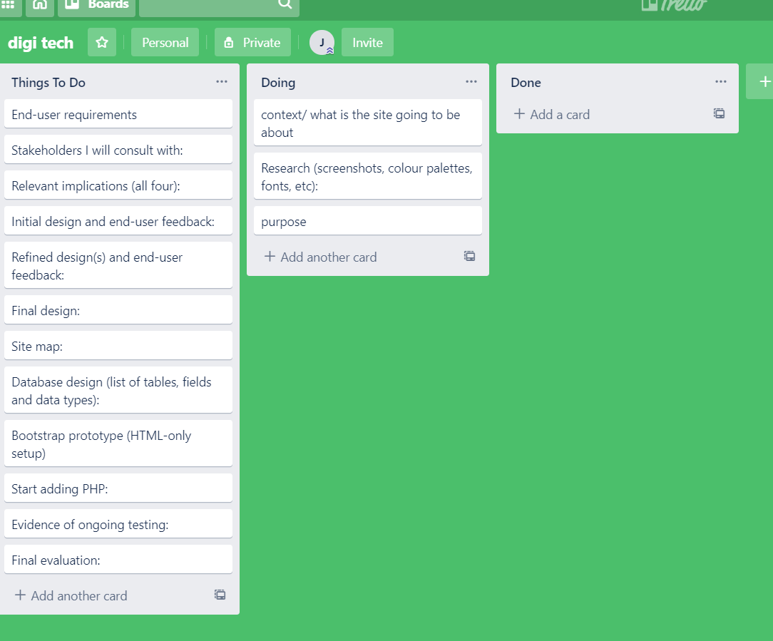

This is when I was in my design stage.

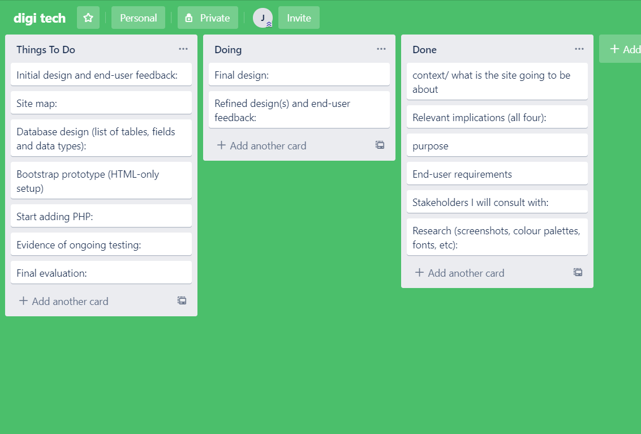

This is when I was coding my website and data base.

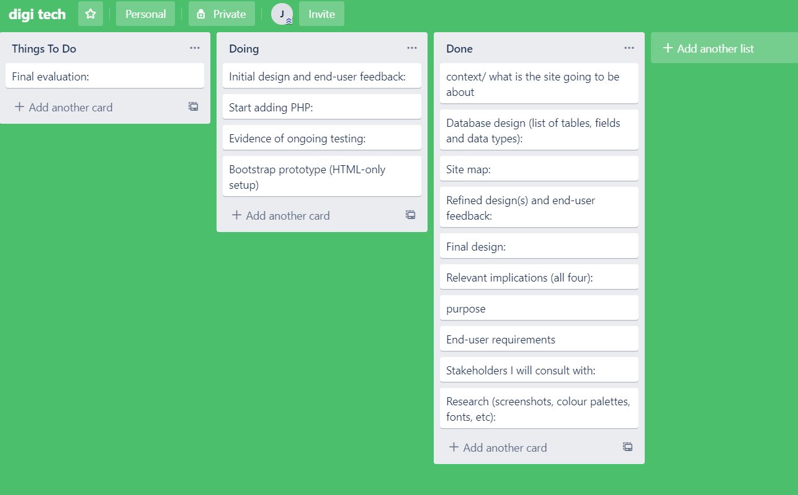

This is when I finshed

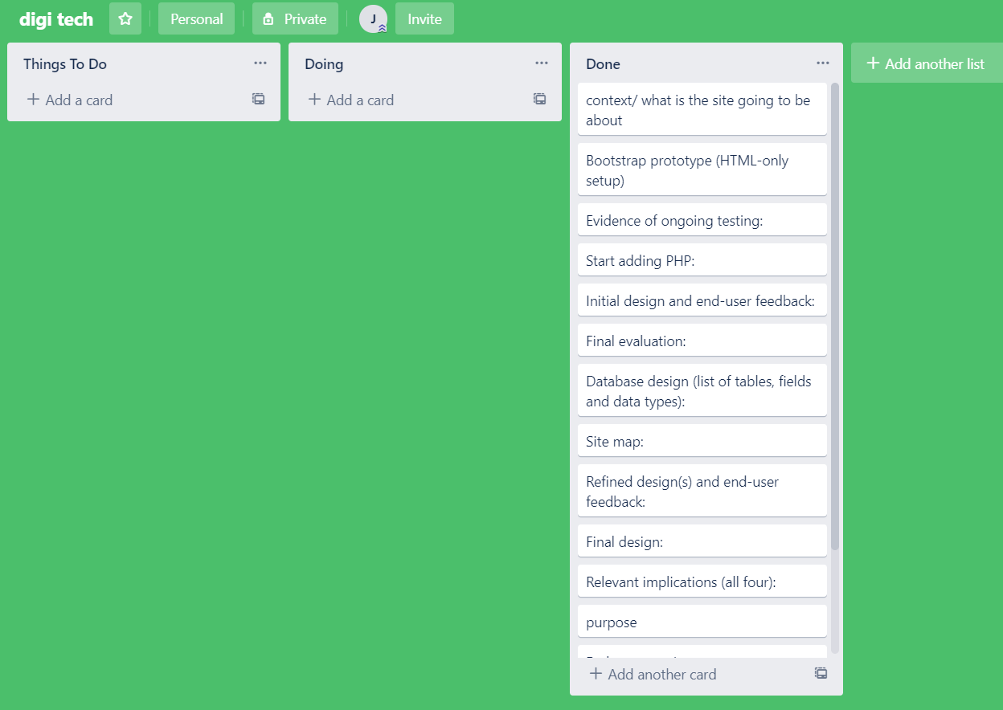

Relevant implications: Aesthetics: My first relevant implication was Aesthetics. The point of Aesthetics implication is to, make it look good and have a pleasing look. The good thing about having a good Aesthetics means that people will enjoy your site and come back again to use your site. Also having a good Aesthetics also means having a nice simplistic design which will also help it look better and will also help with functionality. I made it simple by have minial things on the home page and I also did this by using a goof array of colours.

Relevant implication 2:

Usability: With usability i make my website simple and usable. The good thing about having a simple web site is that it helps with functionality and Aesthetics. I have a constant theme through the hole website Eg colours consistant through the site, links/navbar in the same place on each page. I Think I have done this well because when people use my site they are abel to use it with ease and get round the site easily.

End-user requirements: Explain how your design has addressed the purpose and end-user requirements you identified above. Justify decisions for Excellence.